Task-Based Activity: Wedding cake recipe
Laubach Connection: Laubach Way to Reading (LWR) Book 3, Lesson 6
OALCF Link
Relevant Goal Paths
Apprenticeship, Employment, Independence
Rationale: Learners on the Apprenticeship, Employment and Independence Paths will need to use recipes for a variety of different reasons.

Task-Based Activity Description: The learner will read a brief document (recipe) and make calculations to double the recipe.
Competency, Task Group and Level Indicators
(See Assessment page for performance descriptors)
A: Find and Use Information
A2: Interpret documents
- A2.2 Interpret simple documents to locate and connect information

C: Understand and Use Numbers
C3: Use Measures
- C3.2 Use measures to make one-step calculations

Materials Required
- Pen or pencil and eraser
- Question sheets

Overview
Activity Introduction
This task uses a wedding cake recipe.

Lesson six is a review lesson including the characters that were married in lesson five. Discuss with the learner if they use recipes to cook at home. Discuss the usefulness of recipes and the importance of understanding how to interpret them. Discuss the fact that even though we use the metric system in Canada most recipes are still written using imperial measurement.

New words
Determine any new words that you think are being introduced in the activity and review those words with the learner. Some suggested words to review: granulated, extract, parchment paper. You may also want to review measurement terms with the learner.

Instructions
- Have the learner fill in their name and the date.
- Have the learner complete the pre self-assessment.
- Have the learner complete the task-based activity.
- After completing the activity have the learner complete the post self-assessment.
- After the learner has completed the task-based activity complete the assessment section and review the results with the learner.

Extension activities
- Bring in a variety of different recipes for the learner to interpret.
- Have the learner bring in recipes from home that they are having difficulty understanding.

Task-Based Activity: Wedding cake recipe

Learner Name: _____________________________ Date: ____________________________

Pre self-assessment

I need to improve my skills at reading recipes:
- Yes
- No

Activity
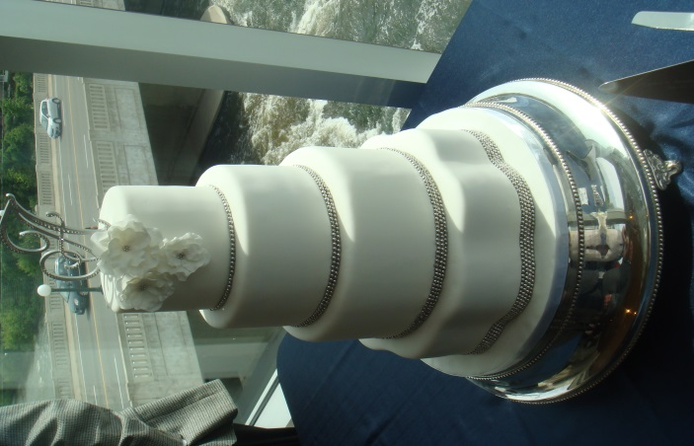
Classic Wedding Cake Recipe
Ingredients
- 6 cups cake flour sifted
- 2 tablespoons baking powder
- 1 1/2 cups butter or margarine, softened
- 3 cups granulated sugar
- 2 cups milk
- 1 teaspoon pure vanilla extract
- 12 egg whites

Makes
12 cups of cake batter
Instructions:
Step 1
Preheat oven to 325°F. Grease bottom of pans and line with waxed paper or parchment paper.
Step 2
Sift together flour and baking powder. Set aside. Cream butter and sugar together until light and fluffy. Set aside. Beat egg whites until stiff, but not dry. Set aside. With mixer at slow speed, add flour mixture to butter mixture, alternately with milk. Beat well after each addition. Beat in vanilla extract. Gently fold egg whites into batter. Pour into prepared pans. Bake until toothpick inserted into center comes out clean.

Source: http://www.wilton.com/recipe/Classic-White-Cake

- In order to make a wedding cake, you will need to double this recipe. How much butter or margarine will you need? __________________________________________

- If you double the recipe how much milk will you need? ______________________________

- How many dozen eggs do you need to buy if you double the recipe? __________________

- Circle, highlight or underline what you need to line the pans with.

What temperature does the oven need to be set at to bake the cake? __________________

Post self-assessment

I think my skills have improved as a result of completing this activity.
- Yes
- No

Learner comments:
_________________________________________________________________________________________________
_________________________________________________________________________________________________
_________________________________________________________________________________________________

Assessment
Task-Based Activity: Wedding cake recipe
Learner Name: _____________________________ Date: ____________________________

Practitioner Name: _______________________________________

Performance Descriptors | Needs Work | Improving | Excellent
A2.2: Interpret simple documents to locate and connect information

- performs limited searches using one or two search criteria
- extracts information from tables and forms
- locates information in simple graphs and maps
- uses layout to locate information
- makes connections between parts of documents
- makes low-level inferences
- begins to identify sources and evaluate information

C3.2: Use measures to make one-step calculations
- calculates using numbers expressed as whole numbers, fractions, decimals, percentages and integers
- understands and uses ratio and proportion
- interprets and represents area and volume using symbols and abbreviations (e.g. m3)
- converts units of measurement within the same system and between systems
- chooses and performs required operation(s); may make inferences to identify required operation(s)
- selects appropriate steps to solutions
- interprets, represents and converts measures using whole numbers, decimals, percentages, ratios and simple, common fractions (e.g. ½, ¼)
- uses strategies to check accuracy (e.g. estimating, using a calculator, repeating a calculation, using the reverse operation)

The learner needs to work on the following:

This task was successfully completed ______ This task needs to be tried again ______

Practitioner Comments:

Learner Comments:

